Week 6

Student Management Portal:

CODE:

App.js:

import './App.css';
import { CalculateScore } from './Components/CalculateScore';

function App() {
return (
<div className="App">
<CalculateScore />
</div>
);
}

export default App;

CalculateScore.js:

import React from "react";
import "../Stylesheets/mystyle.css";

export function CalculateScore() {
const name = "Steeve";
const school = "DNV Public School";
const total = 284;
const goal = 300;
const score = ((total / goal) * 100).toFixed(2);

return (
<div className="score-container">
<h2 className="title">Student Details:</h2>
<p className="name">
<span className="label">Name:</span> <span className="value"> {name}</span>
</p>
<p className="school">
<span className="label">School:</span> <span className="value"> {school}</span>
</p>
<p className="total">
<span className="label">Total:</span> <span className="value"> {total} Marks</span>
</p>
<p className="score">
<span className="label">Score:</span> <span className="value"> {score}%</span>
</p>
</div>
);
}

mystyle.css:

.score-container {
background-color: #ffffff;
margin: 50px auto;
padding: 25px 35px;
width: 440px;
text-align: left;
border: 1px solid #ccc;
border-radius: 12px;
font-family: Arial, sans-serif;
font-size: 18px;
box-shadow: 2px 2px 10px rgba(0, 0, 0, 0.1);
}

.title {
text-align: center;
color: #d32f2f; /* red for title */
margin-bottom: 20px;
font-size: 22px;
font-weight: bold;
}

/* Name */
.name .label {
color: #0a3d91; /* slightly darker blue */
font-weight: 600;
}
.name .value {
color: #2196f3; /* normal blue */
}

/* School */
.school .label {
color: #a01e1e; /* slightly darker red */
font-weight: 600;
}
.school .value {
color: #f28b82; /* light red */
}

/* Total */
.total .label {
color: #6a1b9a; /* deeper violet */
font-weight: 600;
}
.total .value {
color: #c084f2; /* light violet */
}

/* Score */
.score .label {
color: #1b5e20; /* deeper green */
font-weight: 600;
}
.score .value {
color: #81c784; /* light green */
}

Outputs:

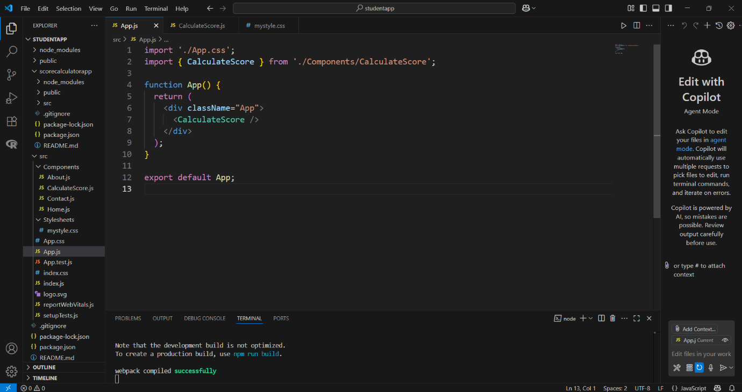

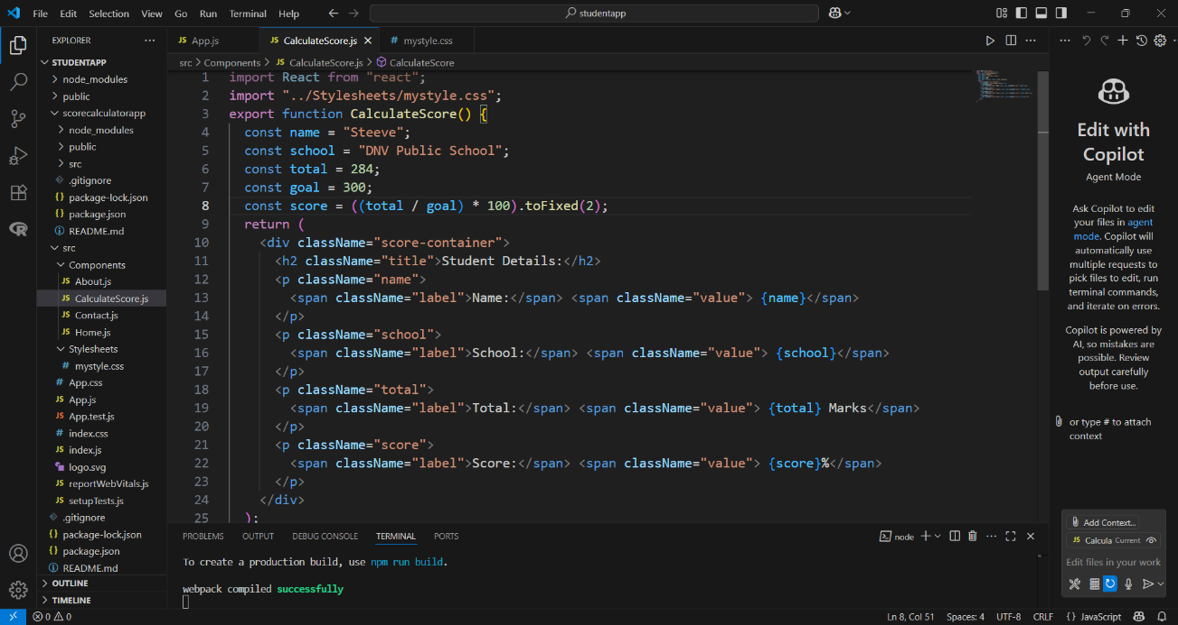

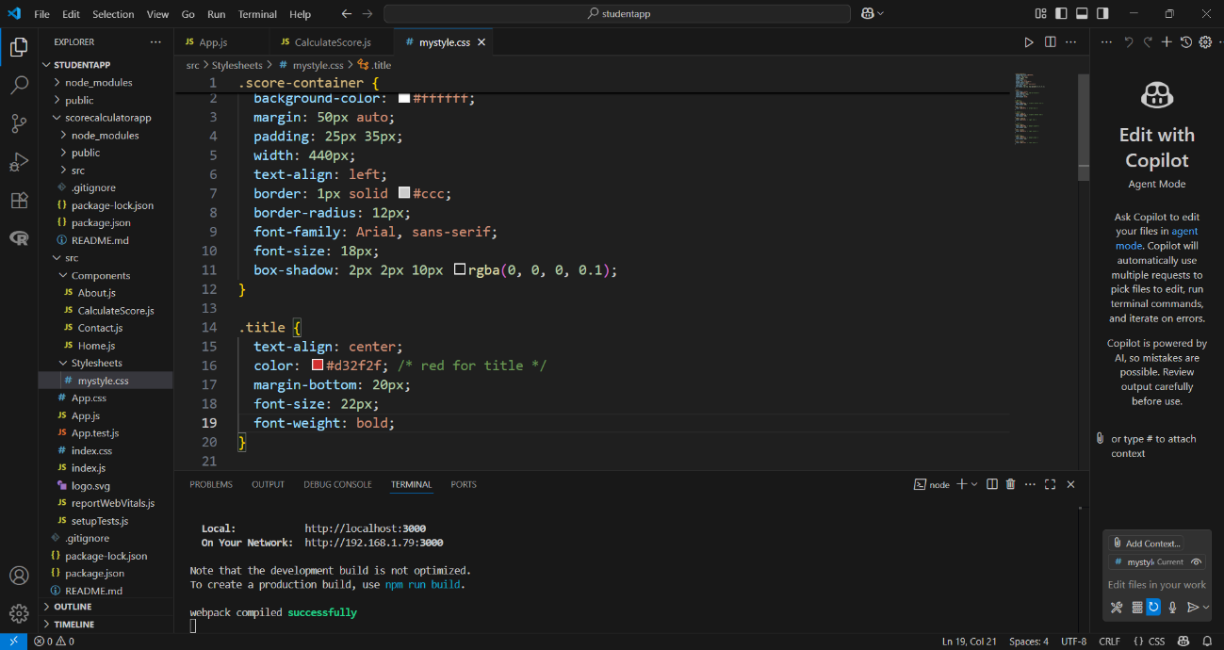

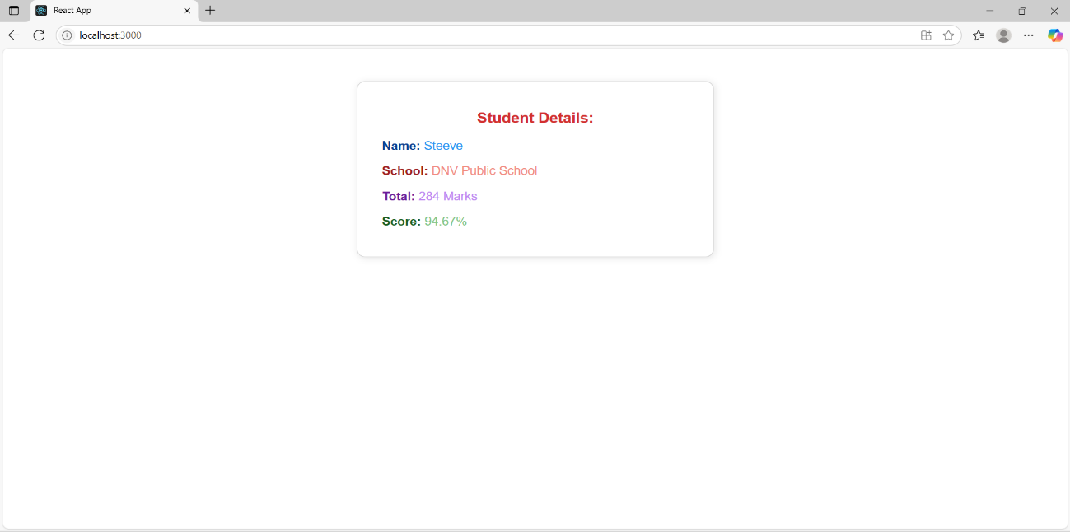

Week 6

Cohort Details:

CODE:

App.js:

import React from 'react';
import Dashboard from './Dashboard';

function App() {
return (
<div>
<Dashboard />
</div>
);
}

export default App;

Dashboard.jsx:

import React from 'react';
import CohortDetails from './components/CohortDetails';
const cohortData = [
{
title: "INTADMDF10-.NET FSD",
startDate: "22-Feb-2022",
status: "Scheduled",
coach: "Aathma",
trainer: "Jojo Jase"
},
{
title: "ADM21JF014 - Java FSD",
startDate: "10-Sep-2021",
status: "Ongoing",
coach: "Apoorv",
trainer: "Elisa Smith"
},
{
title: "CDBJF21025-Java FSD",
startDate: "24-Dec-2021",
status: "Ongoing",
coach: "Aathma",
trainer: "John Doe"
}
];

const Dashboard = () => {
return (
<div>
<h2>Cohorts Details</h2>
{cohortData.map((cohort, index) => (
<CohortDetails key={index} cohort={cohort} />
))}
</div>
);
};

export default Dashboard;

CohortDetails.jsx:

import React from 'react';
import styles from './CohortDetails.module.css';
const CohortDetails = ({ cohort }) => {
const isGreenTitle = cohort.title.startsWith('ADM') || cohort.title.startsWith('CDB');

return (
<div className={styles.box}>
<h3 style={{ color: isGreenTitle ? 'green' : 'blue' }}>
{cohort.title}
</h3>
<dl>
<dt>Started On</dt>
<dd>{cohort.startDate}</dd>

<dt>Current Status</dt>
<dd>{cohort.status}</dd>

<dt>Coach</dt>
<dd>{cohort.coach}</dd>

<dt>Trainer</dt>
<dd>{cohort.trainer}</dd>
</dl>
</div>
);
};

export default CohortDetails;

CohortDetails.module.css:

.box {
width: 300px;
display: inline-block;
margin: 10px;
padding: 10px 20px;
border: 1px solid black;
border-radius: 10px;
}

dt {
font-weight: 500;
}

Outputs:

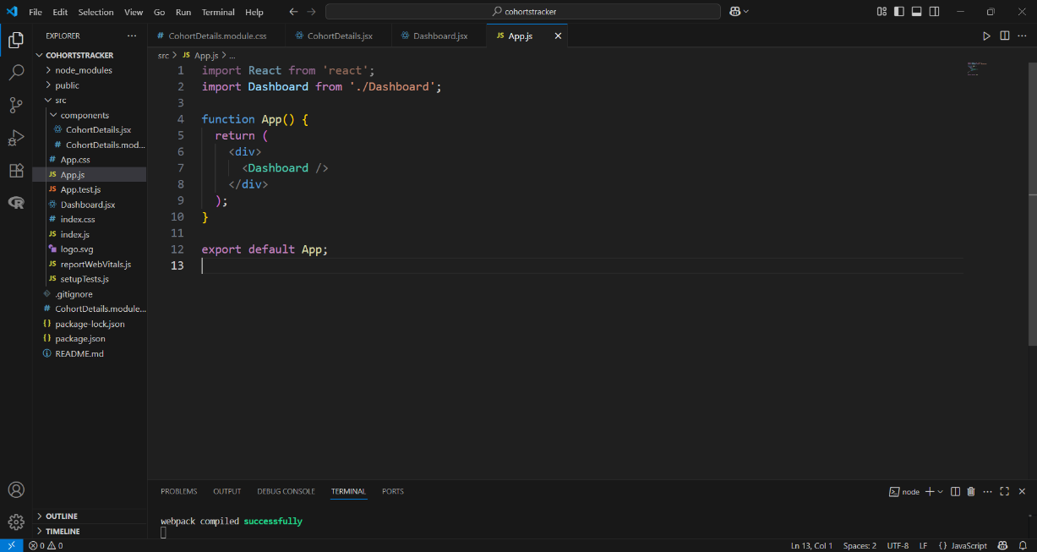

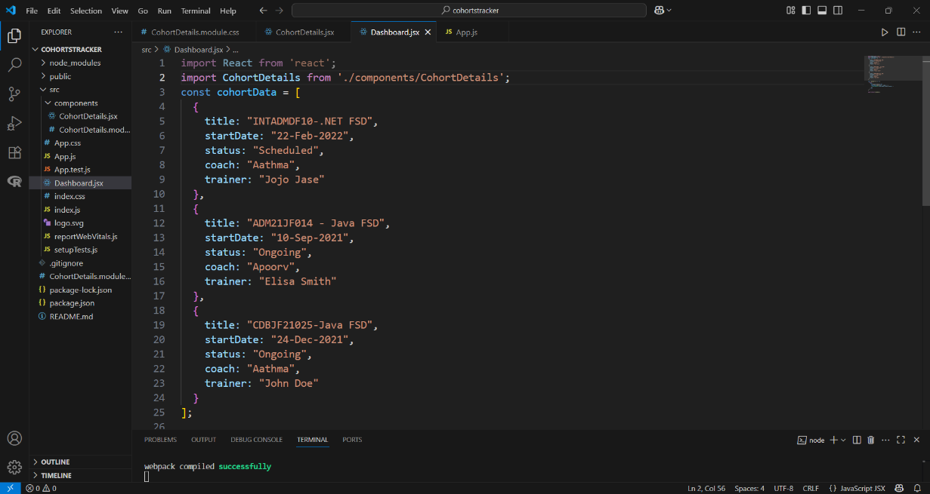

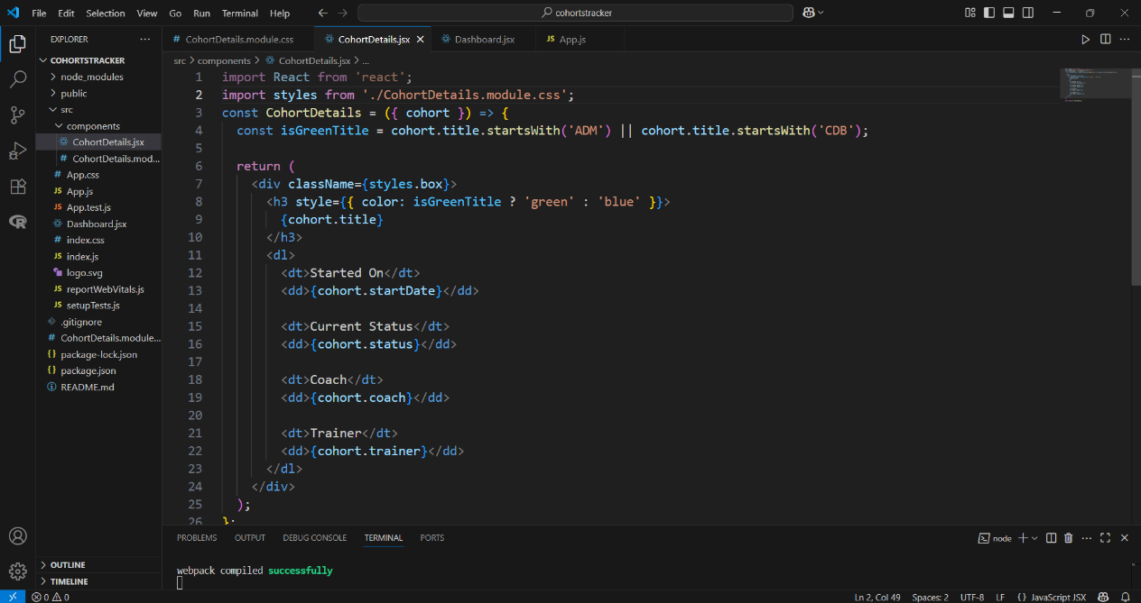

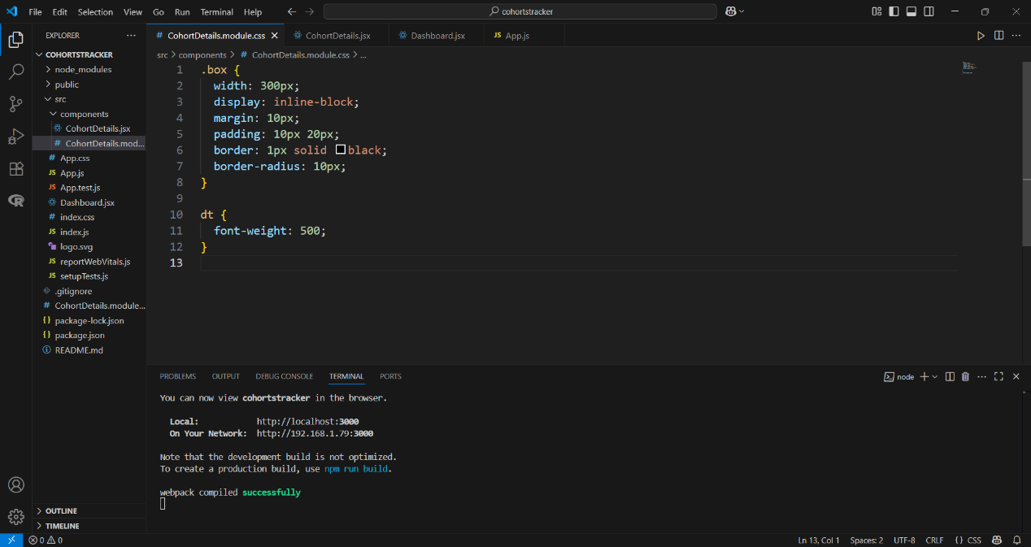

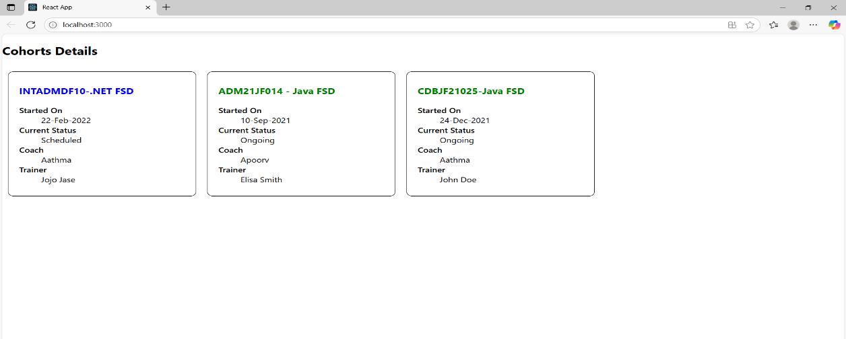

Week 6

Create-react-app:

CODE:

App.js:

import React from 'react';
import './App.css';
import Posts from './Posts';

function App() {
return (
<div className="App">
<Posts />
</div>
);
}

export default App;

Post.js:

class Post {
constructor(id, title, body) {
this.id = id;
this.title = title;
this.body = body;
}
}

export default Post;

Posts.js:

// JS Posts.js UX

import React from 'react';

class Posts extends React.Component {
constructor(props) {
super(props);
this.state = {
posts: []
};
}

loadPosts() {
fetch('https://jsonplaceholder.typicode.com/posts')
.then((response) => response.json())
.then((data) => {
this.setState({ posts: data });
})
.catch((error) => {
console.error('Error fetching posts:', error);
});
}

componentDidMount() {
this.loadPosts();
}

render() {
return (
<div>
<h1>Posts</h1>
{this.state.posts.map(post => (
<div key={post.id}>
<h2>{post.title}</h2>
<p>{post.body}</p>
<hr />
</div>
))}
</div>
);
}

componentDidCatch(error, info) {
alert("An error occurred: " + error.message);
console.error("Error details:", info);
}
}

export default Posts;

Outputs:

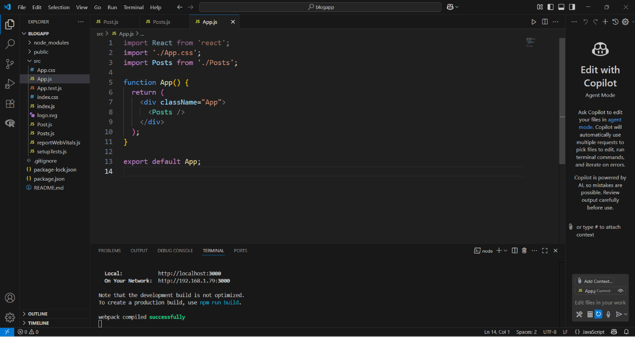

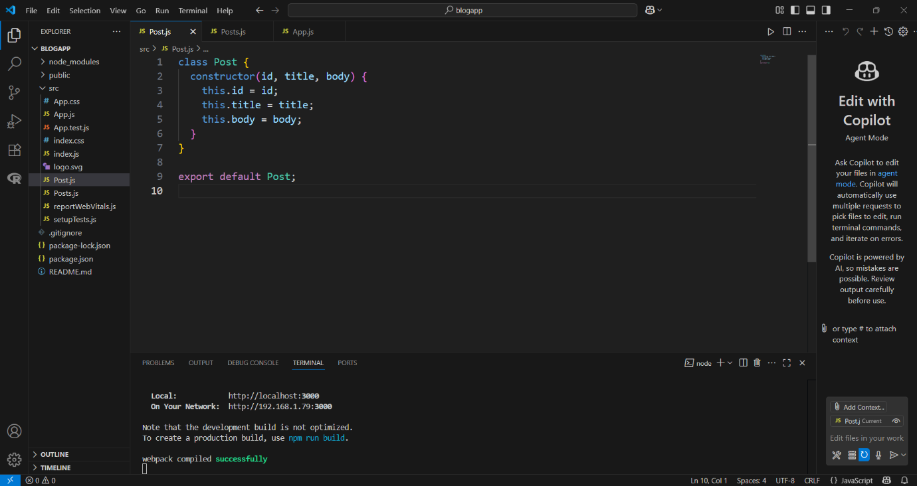

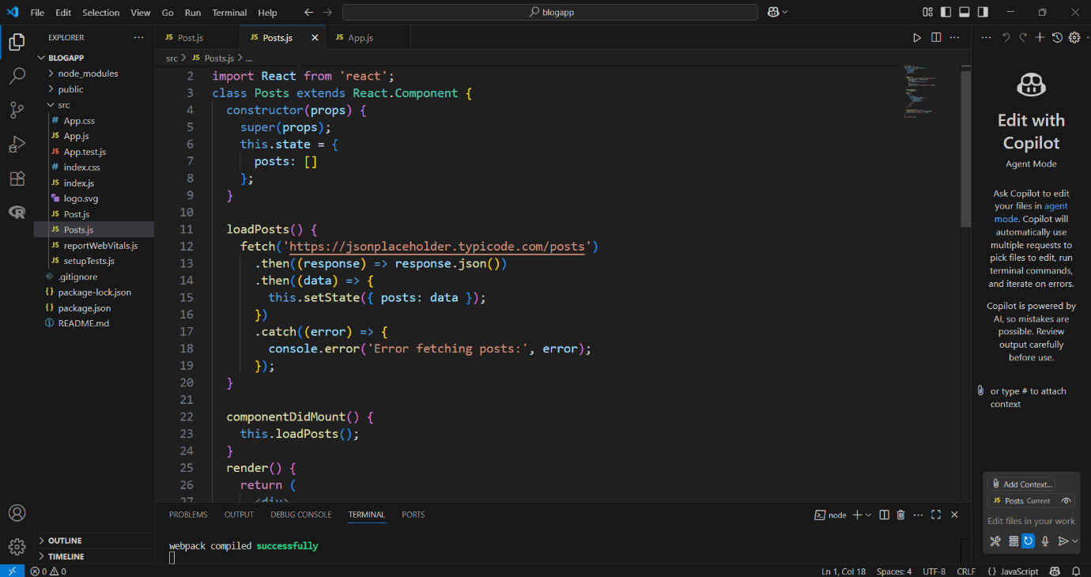

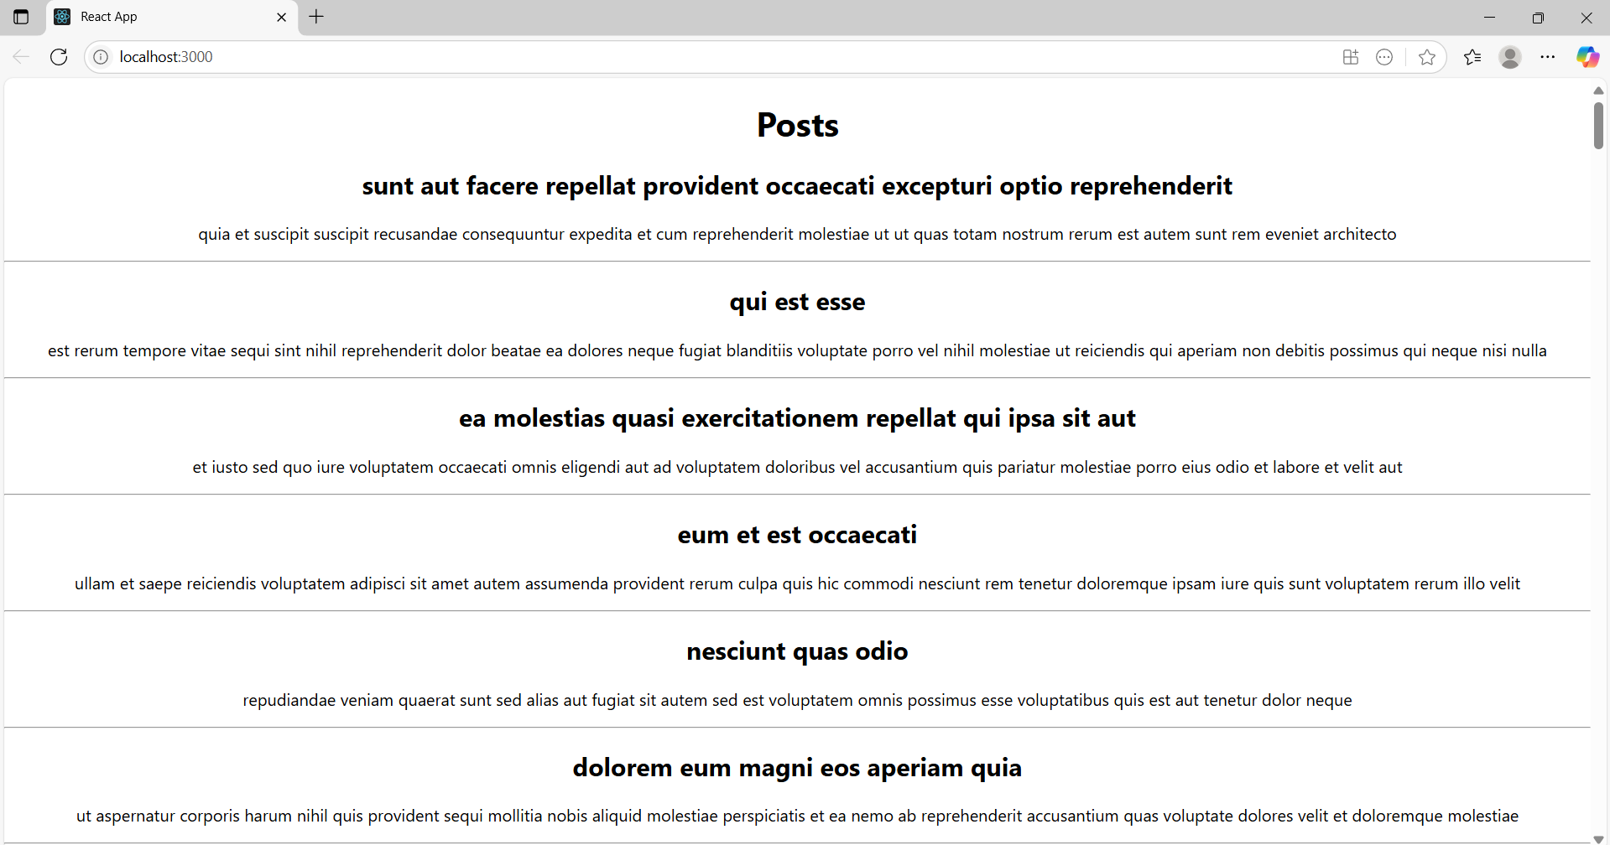

Week 6

My First React :

CODE:

App.js:

import React from 'react';

function App() {
return (
<h1>Welcome to the first session of React</h1>
);
}
export default App;

Outputs:

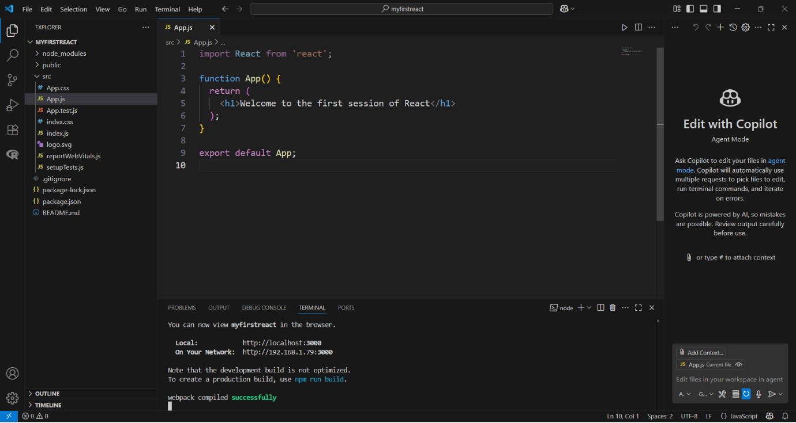

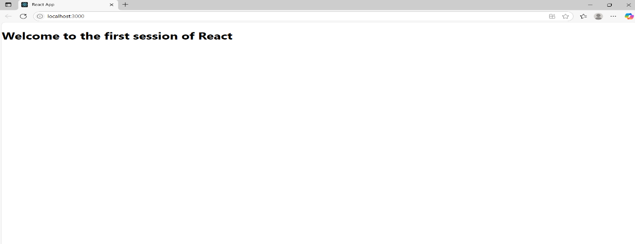

Week 6

Student Management Portal:

CODE:

App.js:

import './App.css';
import Home from './Components/Home';
import About from './Components/About';
import Contact from './Components/Contact';

function App() {
return (
<div className="container">
<Home />
<About />
<Contact />
</div>
);
}

export default App;

App.css:

.App {
text-align: center;
}

.App-logo {
height: 40vmin;
pointer-events: none;
}

@media (prefers-reduced-motion: no-preference) {
.App-logo {
animation: App-logo-spin infinite 20s linear;
}
}

.App-header {
background-color: #282c34;
min-height: 100vh;
display: flex;
flex-direction: column;
align-items: center;
justify-content: center;
font-size: calc(10px + 2vmin);
color: white;
}

.App-link {
color: #61dafb;
}

@keyframes App-logo-spin {
from {
transform: rotate(0deg);
}
to {
transform: rotate(360deg);
}
}
.centered {
text-align: center;
margin-top: 30px;
font-size: 24px;
font-weight: bold;
color: #333;
}

Home.js:

function Home() {
return (
<div className="centered">
<h2>Welcome to Home Page of Student Management Portal</h2>
</div>
);
}

export default Home;

About.js:

function About() {
return (
<div className="centered">
<h2>Welcome to About Page of Student Management Portal</h2>
</div>
);
}

export default About;

Contact.js:
function Contact() {
return (
<div className="centered">
<h2>Welcome to Contact Page of Student Management Portal</h2>
</div>
);
}

export default Contact;

Outputs:

